Lab 7 - Non-parametric Spectrum Estimation

**Group 9**

Dinesh V G

Harsha Nandeeshappa Krishnarajanagar

Preparation

1. Spectrum is the amount of energy present at each frequencies in the signal. If there is no energy present at some frequncy, that means that frequency does not exist in that signal. Example Audio frequncy specrum is from 20Hz to 20KHz. That means an audio signal with have energy spread over these frequencies and outside these frequencies no energy is present.
2. DTFT etc does not give information of the spectrum if there are finite set of observation of a random signal. Therfore we make use of Periodogram. Periodogram is a useful estimator for estimating periodicity but not spectrum as its variance is constant irrespective of the number of samples observed(assymtotically the variance stays constant)
3. Averaging Periodogram - The idea behind it is, to divide the set of N samples into L sets of M samples, compute the [discrete Fourier transform](http://en.wikipedia.org/wiki/Discrete_Fourier_transform) (DFT) of each set, square it to get the power spectral density and compute the average of all of them. This helps in reducing the variance of the estimated signal.
4. Spectra

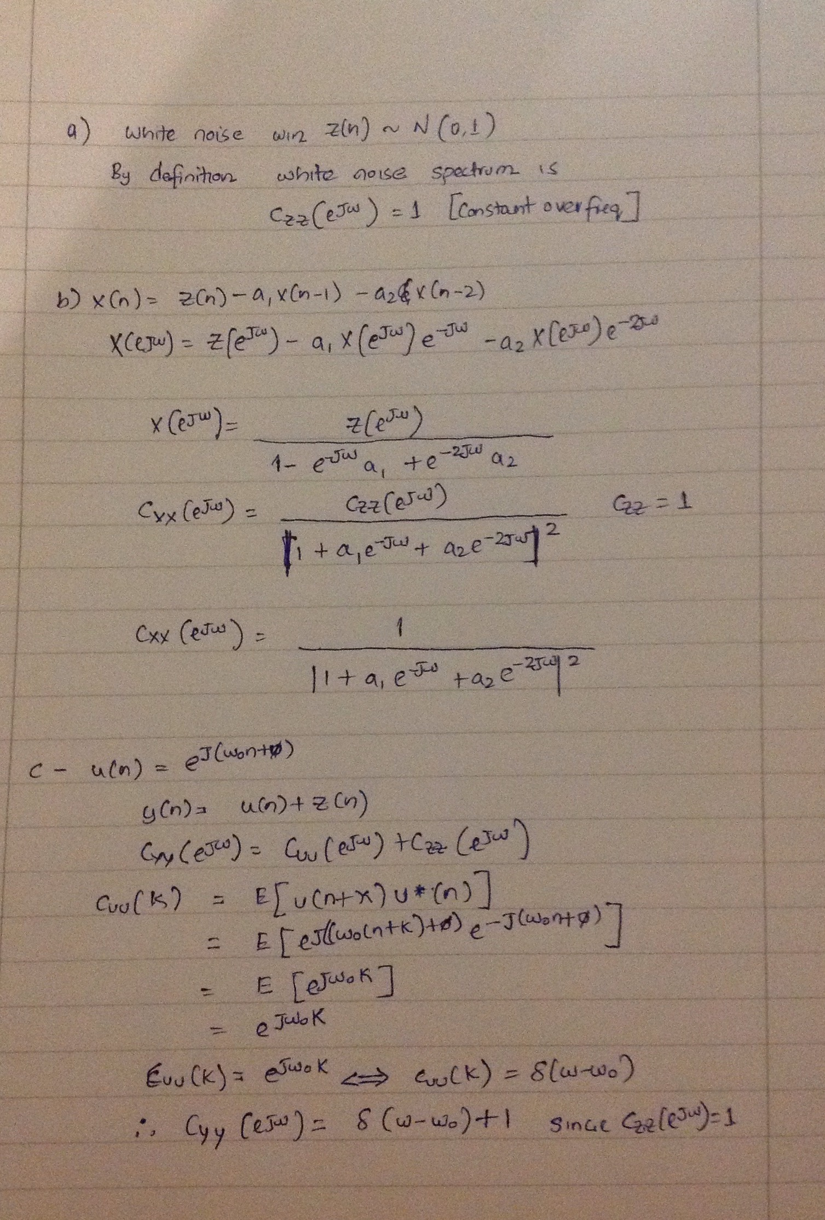

Experiments

4.1 – Windowed , Averaged Periodograms

clc;

clear all;

close all;

load ar7.mat;

%% **Rectangle window**

N=length(X);

L=1;

M=N/L;

window=rectwin(M);

[C w]=spec1(X.',window.',L);

figure(1);

title('Rectangular Window');

subplot(2,2,1); plot(w,C);

title('L=1');

xlabel('\omega/rad');

ylabel('Power density');

L=2;

M=N/L;

window=rectwin(M);

[C w]=spec1(X.',window.',L);

subplot(2,2,2); plot(w,C);

title('L=2');

xlabel('\omega/rad');

ylabel('Power density');

L=5;

M=N/L;

window=rectwin(M);

[C w]=spec1(X.',window.',L);

subplot(2,2,3); plot(w,C);

title('L=5');

xlabel('\omega/rad');

ylabel('Power density');

L=10;

M=N/L;

window=rectwin(M);

[C w]=spec1(X.',window.',L);

subplot(2,2,4); plot(w,C);

title('L=10');

xlabel('\omega/rad');

ylabel('Power density');

%% **Hamming Window**

L=1;

M=N/L;

window=hamming(M);

[C ,w]=spec1(X.',window.',L);

figure(2);

subplot(2,2,1); plot(w,C);

title('L=1');

xlabel('\omega/rad');

ylabel('Power density');

L=2;

M=N/L;

window=hamming(M);

[C ,w]=spec1(X.',window.',L);

subplot(2,2,2); plot(w,C);

title('L=2');

xlabel('\omega/rad');

ylabel('Power density');

L=5;

M=N/L;

window=hamming(M);

[C ,w]=spec1(X.',window.',L);

subplot(2,2,3); plot(w,C);

title('L=5');

xlabel('\omega/rad');

ylabel('Power density');

L=10;

M=N/L;

window=hamming(M);

[C ,w]=spec1(X.',window.',L);

subplot(2,2,4); plot(w,C);

title('L=10');

xlabel('\omega/rad');

ylabel('Power density');

spec1 –

function [ C w ] = spec1(x,window,L)

%SPEC1 Summary of this function goes here

% Detailed explanation goes here

% x, window must be row vectors

N=length(x);

M=N/L;

C_temp=[];

for (l=1:L)

x_truncated=x(M*(l-1)+1:M*l); fft_temp=fft(x_truncated.*window); temp=1/sum(window.^2)*abs(fft_temp).^2;

C_temp=[C_temp; temp];

end

if (L==1) C=C_temp;

else C=mean(C_temp);

end

w=(0:(M-1))*2*pi/M;

end

Result – Rectangular Window

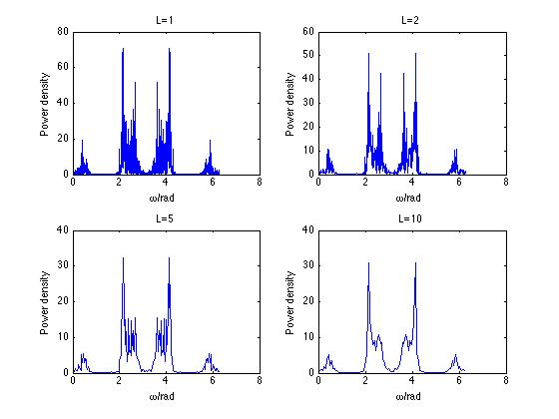

Hamming Window

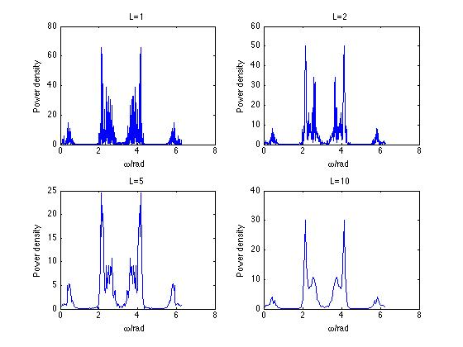

Hamming window provides a smooth version of the estimated spectrum than the periodogram with the same number of segments due to a larger main- lobe width

4.1 – 4 Confidence interval

clc;

clear all;

close all;

load ar7.mat;

N=length(X);

L=5;

M=N/L;

window=hamming(M);

[C w]=spec1(X.',window.',L);

x = norminv([0.025 0.975],0,1);

N_alpha=x(2);

delta=ones(size(C))* 10 * log10(exp(1) * N_alpha/sqrt(L));

logC=10*log10(C);

plot(w,logC-delta,'g',w,logC+delta,'r',w,logC);

title('Confidence Interval of the log spectrum');

xlabel('Normalized frequency \omega/rad');

ylabel('Power density');

legend('Lower bound','Upper bound','Estimated Spectrum'); xlim([0 2*pi]);

Result

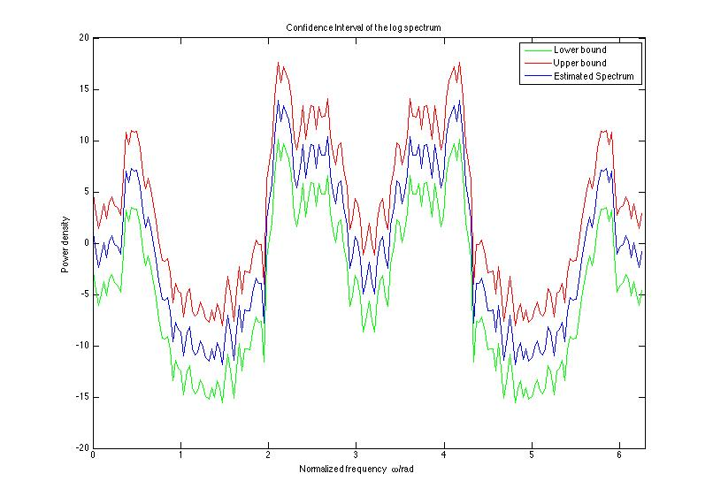

4.2 Smoothed Periodograms

Code

clc;

clear all;

close all;

load ar7.mat;

N=length(X);

m=15;

L=1;

M=N/L;

window=rectwin(M);

[C w]=spec2(X,window,L,m);

plot(w,C);

title('Smoothed Periodogram with m=15');

xlabel('Normalized frequency \omega/rad');

ylabel('Power density');

spec2

function [ C w ] = spec2( x,window,L,m )

%SPEC2 Summary of this function goes here

% Detailed explanation goes here

[C_t w]=spec1(x,window,L);

N=length(C_t);

C=zeros(size(C_t));

for (n=1:N)

l=m;

if (n-l-1 < 0)

l = (n-1);

end

if (n+l > N)

l = (N-n);

end

C(n)=mean(C_t(n-l:n+l));

end

end

Result –

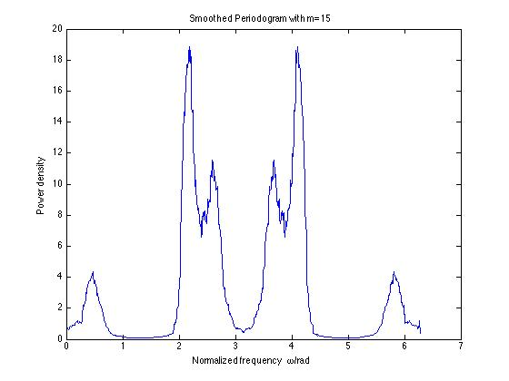

Small m – leads to not so smooth spectrum.

Large m – leads to smooth spectrum but could lead to merging of peaks if m is increased beyond some point.

4.3 Sinusoids in Noise

clc;

clear all;

close all;

N=256;

n=0:(N-1);

z=sqrt(0.5)*randn([1 N]);

X=sin(0.2*pi*n)+2*sin(0.4*pi*n)+sin(0.45*pi*n)+z;

%4.3 - 1

X1=[X(1:64) zeros(1 ,192)];

X2=X;

figure(1);

subplot(2,1,1);

N=length(X1);

L=1;

M=N/L;

window = rectwin(M);

[C1 w1]=spec1(X1,window.',L);

plot(w1/pi,10*log10(C1));

grid;

title('N=64 with zero paddling');

xlabel('Normalized Frequency \omega/ \pi rad');

ylabel('Power density');

N=length(X2);

L=1;

M=N/L;

window=rectwin(M);

[C2, w2]=spec1(X2,window.',L);

subplot(2,1,2);

plot(w2/pi,10*log10(C2));

xlim([0 1]);grid;

title('N=256');

xlabel('Normalized Frequency \omega/ \pi rad');

ylabel('Power density');

%4.3 - 2

X3=X;

figure(2)

N=length(X3);

L=2;

M=N/L;

window=rectwin(M);

[C3, w3]=spec1(X3,window.',L);

subplot(2,1,1);

plot(w3/pi,10*log10(C3));

grid;

title('N=256, L=2');

xlabel('Normalized Frequency \omega/ \pi rad');

ylabel('Power density');

N=length(X3);

L=4;

M=N/L;

window=rectwin(M);

[C3, w3]=spec1(X3,window.',L);

subplot(2,1,2);

plot(w3/pi,10*log10(C3));

xlim([0 1]);grid;

title('N=256, L=4');

xlabel('Normalized Frequency \omega/ \pi rad');

ylabel('Power density');

Result

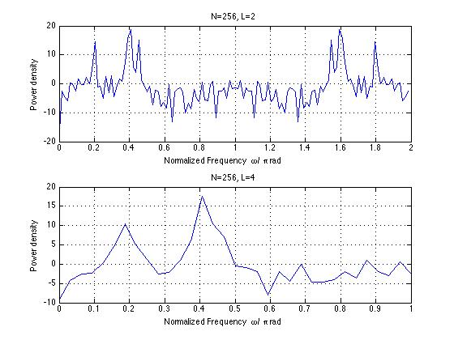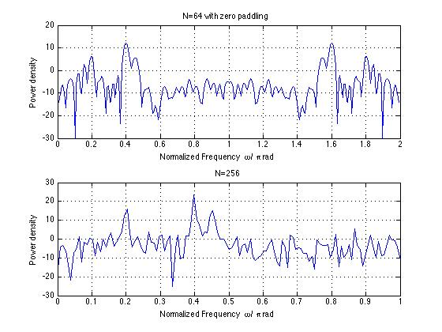

We can observe peaks at 0.2pi + 0.4pi and 0.45pi as expected.

4.4- Biomedical Data

clc;

clear all;

close all;

[y,t] = readfile('resp_fast.txt');

title1 = 'Respiration - Fast ';

compute_periodogram(y,t,title1);

[y,t] = readfile('resp_slow.txt');

title1 = 'Respiration - Slow';

compute_periodogram(y,t,title1)

[y,t] = readfile('group9_respiration.txt');

title1 = 'Cardiac - Group 9';

compute_periodogram(y,t,title1)

**Function code –**

function [] = compute_periodogram(y,t,title1)

t1=t;

x1=y;

x1=detrend(x1);

fs=100;

Wn=40/(fs/2);

figure

N=30;

[b,a]=butter(N,Wn);

x1_process=filter(b,a,x1);

subplot(3,1,1);

ya = x1_process(find(t1<10 & t1>7));

xa = t1(find(t1<10&t1>7))-7;

plot(xa ,ya,'r');

title(title1);

xlabel('Second');

ylabel('Millivolt');

x1=x1_process(1:6*floor(length(x1_process)/6));

N=length(x1);

L=1;

M=N/L;

window=rectwin(M);

[C1 ,w1]=spec1(x1.',window.',L);

subplot(3,1,2);

plot(w1/2/pi*fs,C1);

xlim([0 50]);

title('Periodogram');

xlabel('Hz');

ylabel('Power density');

N=length(x1);

L=6;

M=N/L;

window=rectwin(M);

[C1, w1]=spec1(x1.',window.',L);

subplot(3,1,3);

plot(w1/2/pi*fs,C1);

title('Averaged Periodogram with L=6');

xlabel('Hz');

ylabel('Power density');

Result –

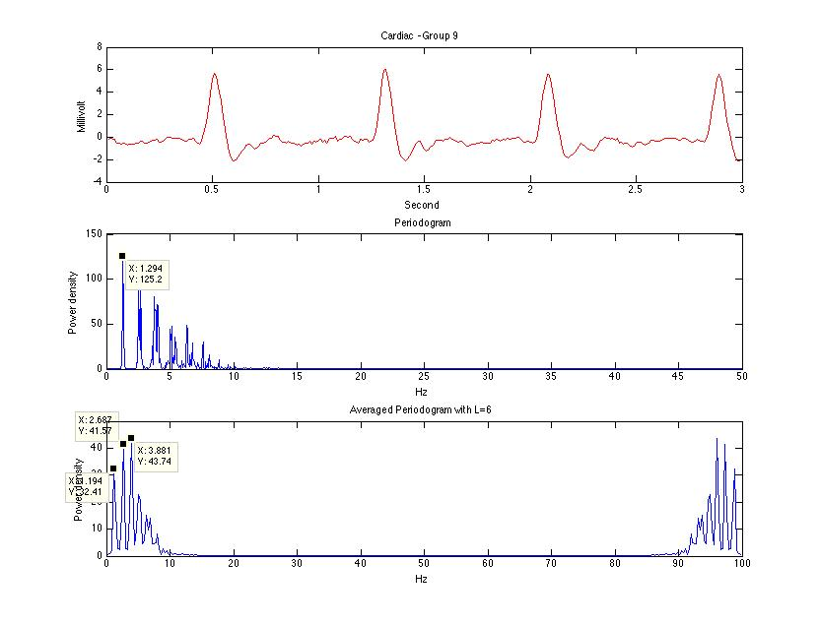

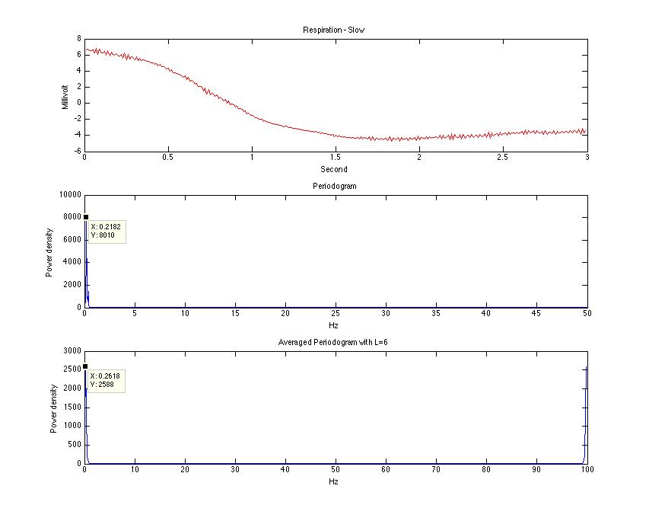

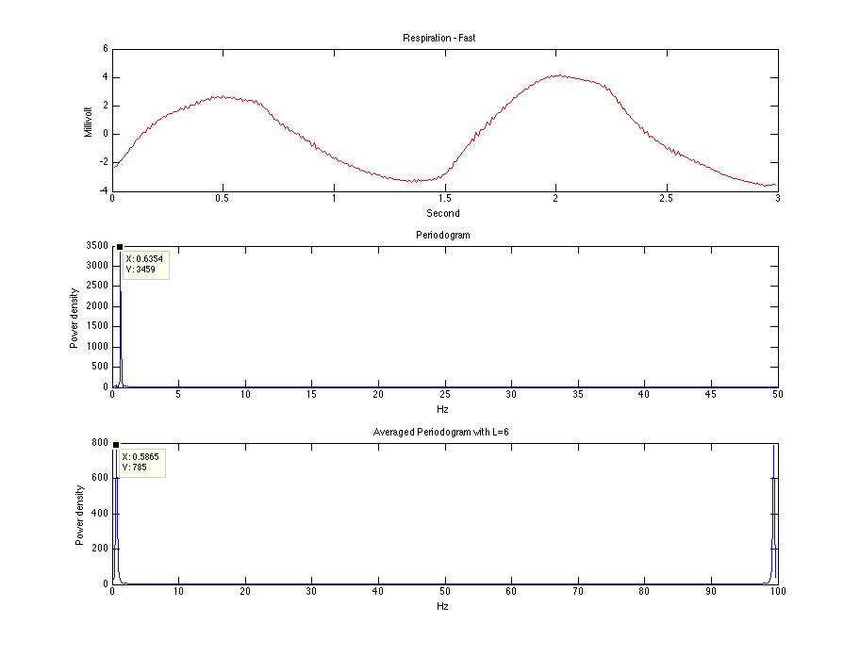

Heart rate – 77.4 bpm

Breath rate – Slow – 13

Breath rate – Fast - 38